Collecting and Analysing Logs with Amazon CloudWatch Logs Insights

A1. What this lab is about
Imagine you have just joined the team that runs an online shop. The shop follows a classic n-tier architecture: a web tier that answers customers, and a database tier behind it that stores the data. Overnight, someone reports odd behaviour: page errors, strange log-in attempts, and database calls that fail. As a Site Reliability Engineer (SRE) your job is to find out what is going on, and you can only do that if the systems write logs and those logs are in one place where you can search them.
In this lab you will switch on and connect the logging for that small shop, then use Amazon CloudWatch Logs Insights to search it like an investigator. A background “traffic generator” keeps the environment busy with a realistic mix of good requests, mistakes and suspicious behaviour, so there is always something to find.
You will work on your own Linux web server. Behind it sits one database shared by the whole class. Everything you create by hand carries your trainee ID so that you and your classmates do not tread on each other.
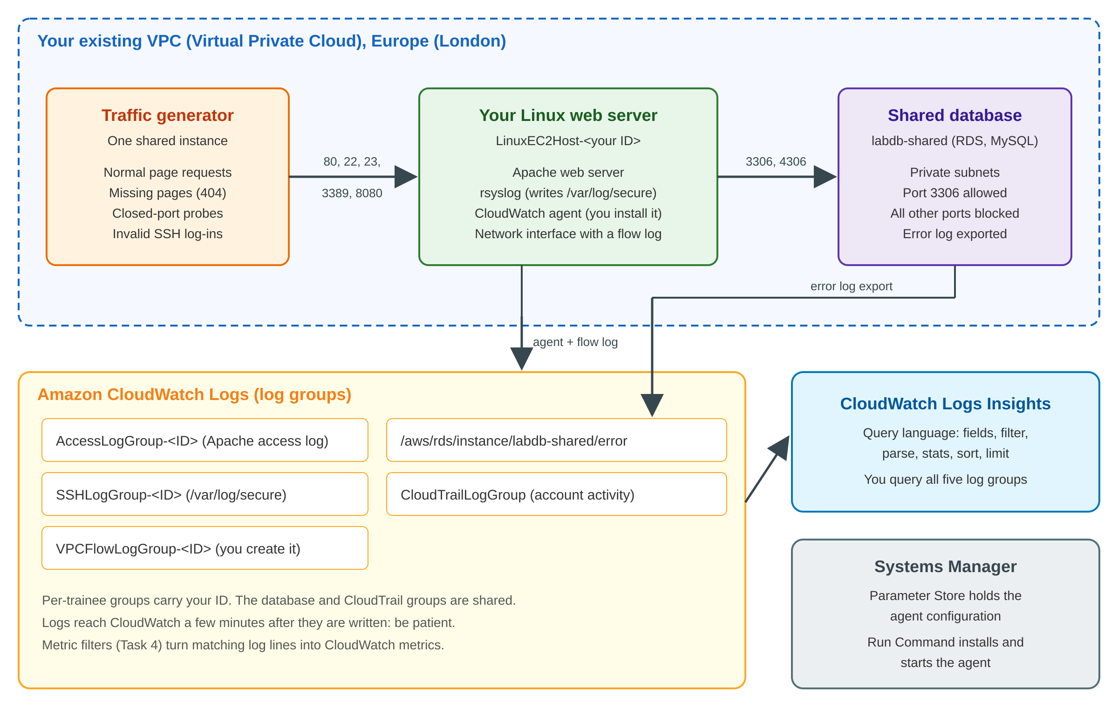
Caution
Logs take time. A log line written on the server usually appears in CloudWatch after a minute or two. Flow logs and database logs can take several minutes more. If a log group looks empty, wait and refresh before assuming something is wrong. This is why the lab asks you to switch things on early.

You Instructor will give you the information for the lab in a .txt file which you can use throughout the lab

Task 1. Set up the logging agent with Systems Manager
The CloudWatch agent is a small program that runs on the server, reads log files and sends them to CloudWatch Logs. You will install it and start it remotely with AWS Systems Manager (a service for managing and automating tasks on your instances), without logging in to the server. The settings the agent should use are already stored for you in Parameter Store (a Systems Manager feature that holds configuration values).

Task 1.1. Check the server has its permissions
For Systems Manager to manage a server, the server needs an IAM (Identity and Access Management) role. It was attached for you. Check it.
- In the console search bar, search for and choose EC2. In the left menu choose Instances.
- Select the box next to LinuxEC2Host-<ID>. Choose Actions, then Security, then Modify IAM role.
- Notice that a role is already attached. Choose Cancel. You have only looked, not changed anything.

Task 1.2. Test the web server
Your server runs the Apache web server and has no public address, so you will look at it from the inside using Session Manager (a Systems Manager feature that opens a command line in the browser).
- On the Instances page, select LinuxEC2Host-<ID> and choose Connect. Choose the Session Manager tab and then Connect.
- In the terminal that opens, type the command below and press Enter. You should see a short web page that mentions your trainee ID.
Command
curl -s http://localhost/

Task 1.3. Install the CloudWatch agent
- In the console search bar, search for and choose Systems Manager. If a banner warns about missing permissions for the new experience, you can ignore it.
- In the left menu, under Node Tools, choose Run Command, then Run command.
- Configure the following:
  - Command document: select AWS-ConfigureAWSPackage. If you cannot see it, use the search box or the page arrows.
  - Action: Install. Name: AmazonCloudWatchAgent.
  - Target selection: choose Specify instance tags. For Tag key enter CloudwatchAgentInstalled. For Tag value enter your trainee ID <ID>. Choose Add.
  - Output options: select Enable an S3 bucket. Choose the bucket named on your handout (it contains “logbucket”). For S3 key prefix enter <ID>.
- Choose Run. Within a minute the status should change to Success. If it does not, choose the refresh button.
Note
Tags are labels attached to AWS resources. In a company with thousands of servers you would target a tag rather than pick servers one by one. Here the tag value is your trainee ID, so your command touches only your own server. The command output is saved to the S3 bucket, which helps when something goes wrong.

Task 1.4. Start the agent with its configuration
- Back in Run Command, choose Run command again.
- Configure the following:
  - Command document: select AmazonCloudWatch-ManageAgent.
  - Optional Configuration Location: enter ConfigParamForEC2s-<ID>. This field is required.
  - Target selection: choose Specify instance tags. Tag key: MonitoringConfig. Tag value: BasicMixOSMonitoring-<ID>. Choose Add.
  - Output options: enable the S3 bucket from your handout again, with S3 key prefix <ID>.
- Choose Run and wait for Success.
Look at the configuration you just applied: in Systems Manager choose Parameter Store and open ConfigParamForEC2s-<ID>. It is JSON (JavaScript Object Notation). Find the two log files the agent collects and the log groups they go to.

Task 1.5. Confirm logs are arriving (come back to this after Task 2)
- Search for and choose CloudWatch. In the left menu, under Logs, choose Log Management.
- Open AccessLogGroup-<ID>. You should see a log stream whose name ends in -http.log. Open it and read a few lines. Then check SSHLogGroup-<ID> for a stream ending in -secure.log.

Task complete
Your server now ships its web and system logs to CloudWatch Logs.

Task 2. Network logging with VPC Flow Logs
VPC Flow Logs record information about the IP (Internet Protocol) traffic going to and from a network interface: who talked to whom, on which port, and whether the traffic was accepted or rejected. They are one of the best tools for spotting unexpected network behaviour. In a shared environment you would normally switch them on for a whole VPC. Because this VPC belongs to everyone, you will switch them on for your own server’s network interface only.

Task 2.1. Create a log group for the flow log
- In CloudWatch, choose Log Management and then Create log group.
- For Log group name enter VPCFlowLogGroup-<ID>. Choose Create.

Task 2.2. Find your server’s network interface
- In EC2, choose Instances and select LinuxEC2Host-<ID>. Open the Networking tab.
- Under Network interfaces, note the Network interface ID (it starts with eni-) and the Private IPv4 address. Write the address down: you need it for the queries later.

Task 2.3. Create the flow log
- In the EC2 left menu, under Network & Security, choose Network Interfaces. Select the interface with your ID.
- Choose Actions, then Create flow log.
- Configure the following:
  - Name: flowlog-<ID>. Filter: All.
  - Maximum aggregation interval: 1 minute (so records appear sooner).
  - Destination: Send to CloudWatch Logs. Destination log group: VPCFlowLogGroup-<ID>.
  - Service role: LogsLab-VPCFlowLogsRole. Log record format: AWS default format.
- Choose Create flow log.

Note
A flow log needs a role that lets the flow-log service write into your log group, and the role must trust that service. The role was created for you. It can take several minutes after creation before the first records appear.

Task 3. Database logging: find and read the log
Publishing database logs to CloudWatch Logs lets you search them, keep them in durable storage and alarm on them. In a real project you would switch this on for each database. Because the whole class shares one database, and changing the setting involves a reboot that would interrupt everyone, your instructor switches it on once (and may show you how, live). Your job is to find it and understand it.
- Search for and choose Aurora and RDS. Choose Databases and open labdb-shared. Do not choose Modify, Actions or Reboot.
- Open the Configuration tab and look for the setting that shows which logs are published to CloudWatch Logs. You should see the error log.
- Go to CloudWatch, then Log Management. Find the log group /aws/rds/instance/labdb-shared/error and open one of its log streams. Read the first few lines.

Task 4. Validate and explore the logs with Logs Insights
CloudWatch Logs Insights lets you search and analyse log data interactively with a purpose-built query language. A query is a series of commands joined by the pipe symbol |. The commands you will meet are:
Command | What it does
fields | Chooses which fields to show
filter | Keeps only the log events that match a condition
parse | Extracts new fields from the text of a message, for example with a pattern
stats | Counts or sums events, optionally grouped by a field or by a time bucket such as bin(5m)
sort and limit | Orders the results and keeps only the first few

To run a query: in CloudWatch choose Logs, then Log Analytics (or Logs Insights, depending on your console). In Query scope, select the log group named in the example (and remove any others). Choose the Logs Insights QL query language if asked. Paste the query, choose Run, and set the time range at the top to the last 1 hour.
Caution
Your account may contain log groups from other trainees. Always check that the log group in the query scope ends with your own ID before you run a query. Replace <ID> and <your private IP> in the queries with your own values.

Example 1. Web server traffic and access patterns
Your Apache web server writes one line per request. A line looks like: the caller’s IP address, the time, the request (such as GET /missing.html HTTP/1.1), the status code (200 means success, 404 means not found) and the size.
Command
fields @timestamp, @message
| sort @timestamp desc
| limit 20
Query scope: AccessLogGroup-<ID>. Run this first query to read the latest events:
Now count the hits per 5-minute:
Command
stats count(*) as hits by bin(5m)
Finally, break the traffic down by status code:
Command
parse @message /" (?<status>\d{3}) /
| stats count(*) as requests by status
| sort requests desc

Example 2. Find database calls that are not on the legitimate port
MySQL listens on port 3306, so calls to the database on that port are expected. Calls to other ports are either mistakes or someone looking for a way in. Your web server is the “web tier” calling the “database tier”, so its flow log shows these calls leaving the server.
Query scope: VPCFlowLogGroup-<ID>. Replace <your private IP> with the private address you noted in Task 2.2, keeping the quotes. Run:
filter srcAddr = '<your private IP>' and dstPort < 32768 and dstPort != 53 and dstPort != 80 and dstPort != 123 and dstPort != 443 and dstPort != 3306
| stats count(*) as calls by dstAddr, dstPort, action
| sort calls desc
| limit 20

Example 3. Look at the database error log
Query scope: /aws/rds/instance/labdb-shared/error (remove other groups). Run:
fields @timestamp, @message
| sort @timestamp desc
| limit 50

Now find the failed log-ins, and then narrow them to your own server by adding your private IP:
fields @timestamp, @message
| filter @message like /Access denied/
| filter @message like /<your private IP>/
| sort @timestamp desc
| limit 20

Example 4. Rejected network calls by source
Now look at traffic your server’s network rules refused. This is where probing and scanning shows up.
Query scope: VPCFlowLogGroup-<ID>. Run:
filter action = "REJECT"
| stats count(*) as rejections by srcAddr, dstPort
| sort rejections desc
| limit 20

Knowledge check
Which address is being rejected most, and on which ports? Do you recognise the address? (Compare it with the busiest address in your access log, Q3 in Task 5.) What does that tell you about whose behaviour this is?

Example 5. Create a metric filter for 404 errors, then graph it
Searching logs after the event is useful. Counting problems continuously is better, because then you can graph and alarm on them. A metric filter watches a log group and turns matching lines into a CloudWatch metric.
- In CloudWatch, choose Log Management, tick AccessLogGroup-<ID>, then Actions, then Create metric filter.
- On Define pattern: for Filter pattern enter " 404 " (including the quotation marks and the spaces). For Select log data to test, choose the stream that ends with http.log, then choose Test pattern. You should see matching lines. Choose Next.
- On Assign metric enter:
  - Filter name: accesslogs-404-errors-<ID>
  - Metric namespace: WebsiteLogMetrics
  - Metric name: accesslogs-404-errors-<ID>
  - Metric value: 1. Default value (optional): 0.
- Choose Next, then Create metric filter.
- In the left menu, under Metrics, choose All metrics. Choose WebsiteLogMetrics, then Metrics with no dimensions. (If it is missing, wait a few minutes and refresh.)
- Tick your metric. On the Graphed metrics tab set Statistic to Sum and Period to 1 Minute. Above the graph choose 1h. Hover over the line to see the 404s per minute.

Task complete
You have validated your logs, explored them with Logs Insights and turned a log pattern into a metric.

Task 5. Challenge: log discovery
Use what you have learned to answer these questions. Write your answers down; your instructor will go through them with you. Start from the examples above and adapt them. Check the log group in the query scope each time.
# | Question | Log group to use
Q1 | How many successful web requests (status 200) did your server answer, per 10 minutes, in the last hour? | AccessLogGroup-<ID>
Q2 | Which IP addresses are calling the database on port 3306? Are those servers making any other calls to the database tier? Is that a cause for concern? Then find which client addresses are failing in the shared database error log. | VPCFlowLogGroup-<ID> and /aws/rds/instance/labdb-shared/error
Q3 | What are the top 20 source IP addresses in your web access log? | AccessLogGroup-<ID>
Q4 | What did you (your IAM user) do most recently in the account, from which IP address? | CloudTrailLogGroup
Q5 | Is anyone trying to log in to your server over SSH (Secure Shell, port 22)? Which IP address, and which user names do they try? | SSHLogGroup-<ID>

Tip
Useful building blocks: counting by a field is stats count(*) as n by field. Pulling a value out of text is parse @message /pattern/. Grouping by time is by bin(10m). CloudTrail fields are written with dots, for example userIdentity.userName. CloudTrail events reach CloudWatch about five minutes after they happen.

Task 6 (optional). SRE extension: from logs to reliability
Good SREs turn raw logs into Service Level Indicators (SLIs), Service Level Objectives (SLOs) and alerts, then write down what to do when they fire.
- An SLI from the access log. Run the status-code query from Example 1 again over the last 30 minutes. Define the SLI “proportion of requests that were not a 404”. Work it out from the counts. Then set an SLO of 95 per cent and calculate how much of your error budget (the failure the SLO allows) has been used.
- Is the SLI fair? Look at the 404 paths again. Some look like scanners asking for pages that never existed, not customers. Redefine the SLI so that it measures only what a customer would experience. Explain your choice in one sentence.
- Alert on SSH probing. Create a metric filter on SSHLogGroup-<ID> with the filter pattern "Invalid user", named ssh-invalid-user-<ID> (namespace WebsiteLogMetrics, value 1). Then create a CloudWatch alarm on that metric named <ID>-ssh-invalid-user: statistic Sum, period 5 minutes, threshold greater than or equal to 1. Do not add notification actions. Watch it go to In alarm.
- Write a mini runbook (a short “what to do” page) for that alarm: what it means, how to confirm with Logs Insights, who to tell, and how to close it. Five or six lines is enough.

Finish
- Share your Task 5 answers and any surprises with the instructor.
- Do not delete anything. The instructor removes the environment, including your server and log groups, after the class.
- Sign out of the console.

